AWS Task-1

- Created the Windows server EC2 instance
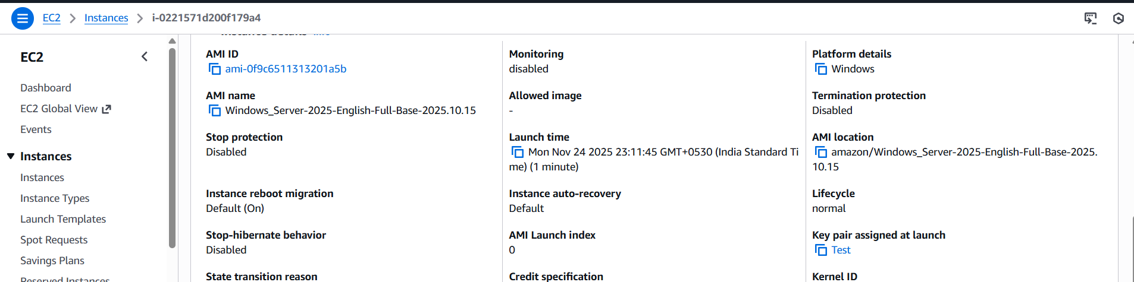

- Downloaded the RDP file and connected the windows WC2 instance
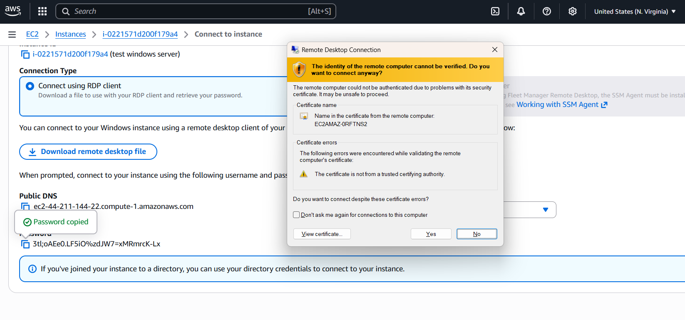
- This is the screenshot of the system information of the windows EC2 server inside the RDP
